**Introduction to Linux Administration**

**Install Virtual Box**  
If not already installed, install [Virtual Box](http://www.virtualbox.org/) virtualisation software. Install the Virtual Box Extension Pack. Download the latest version of [Fedora](http://www.fedoraproject.org). Create a virtual machine for Fedora.

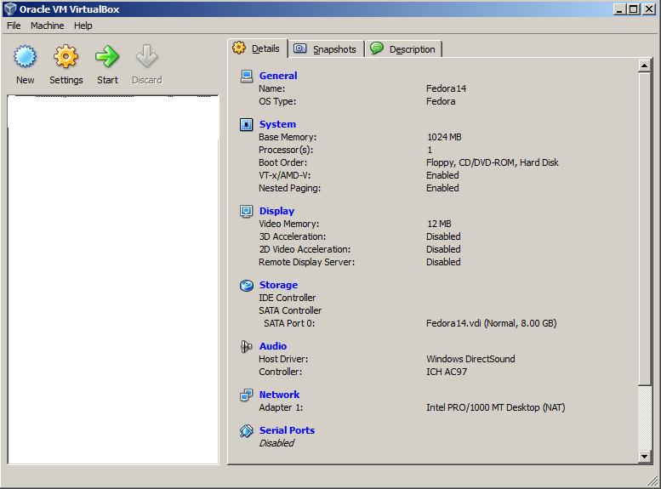

Click on New and it will launch the wizard.

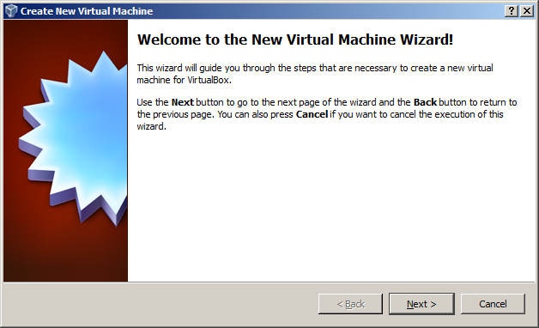

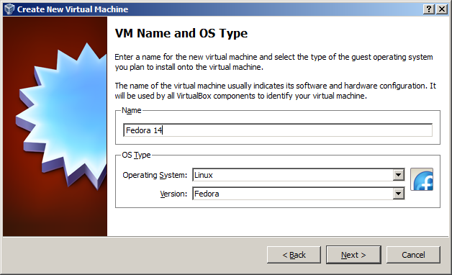

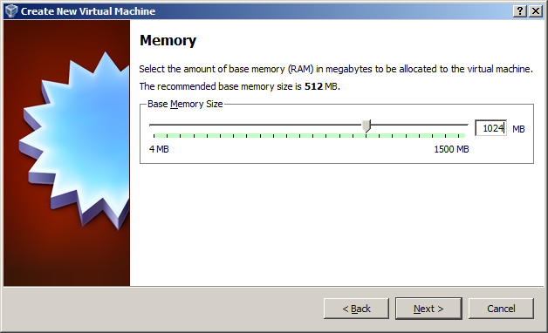

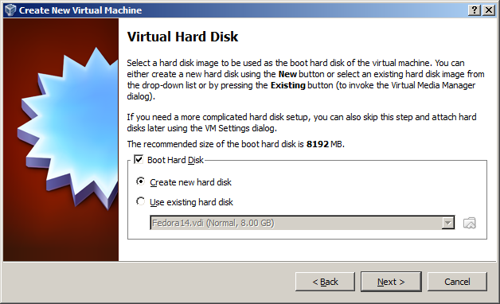

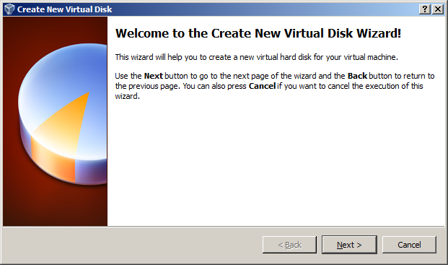

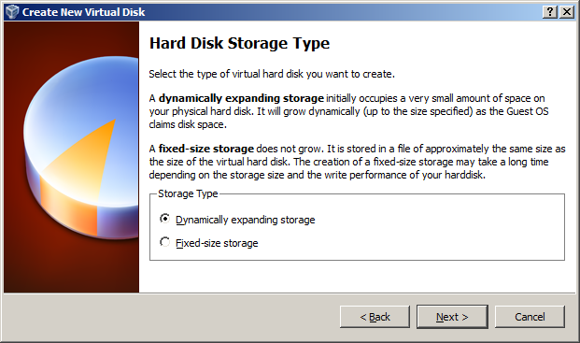

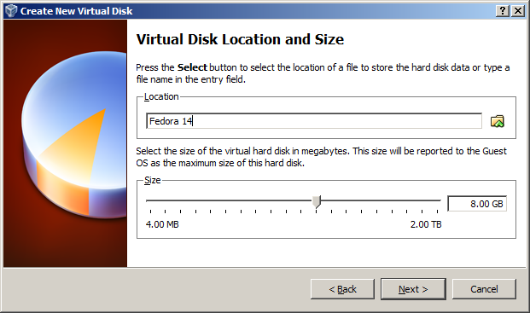

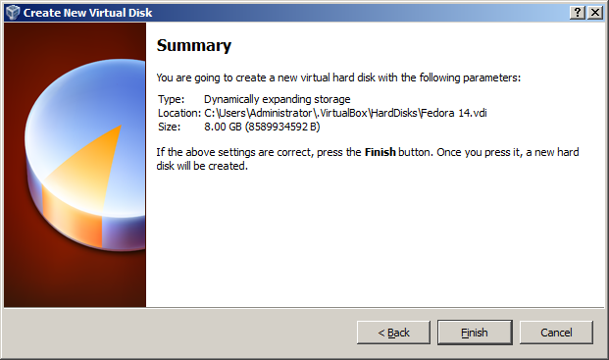

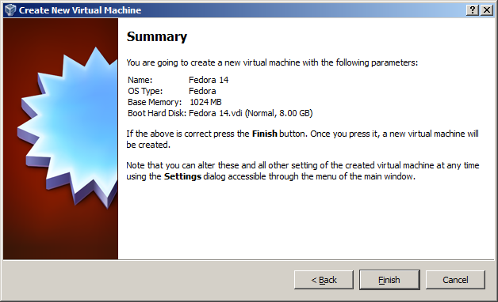

Start the new virtual machine.  
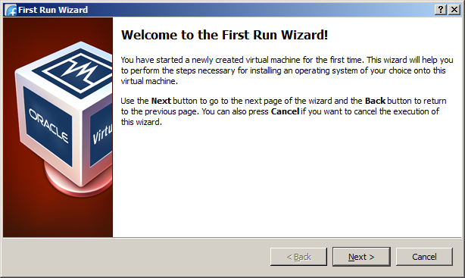

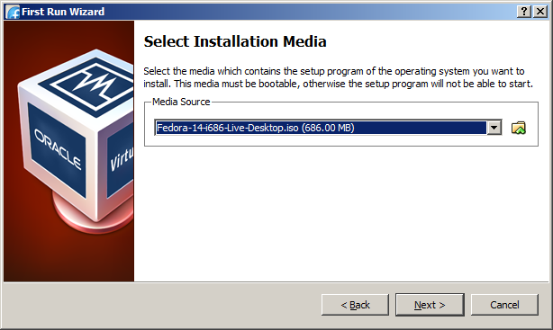

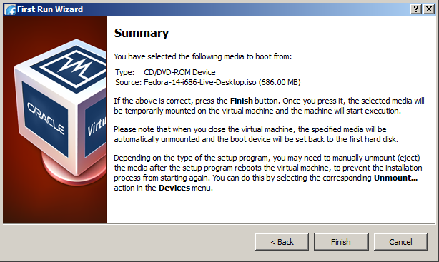

The Fedora Live CD boots. On the desktop, click on the Install to hard drive option (also accessible via Applications -> System Tools -> Install to Hard Drive) and complete the Fedora installation.   
  
On the Fedora Virtual Machine settings, under Storage, remove the IDE controller setting pointing to the Fedora ISO image or the VM will do a Live CD image each time instead of booting from the Virtual Hard Disk.

